Journey of Food – Task 4 Chloe H

**Mouth and Oesophagus**

The chicken breast enters the mouth where the process of digestion begins. The action of chewing and grinding of the teeth begin the process of mechanical digestion which helps the chicken to be broken down into smaller fragments that are easier for the body to digest. Within the mouth are salivary glands which produce saliva. Saliva contains enzymes called salivary amylase. Once food and saliva mixture are thoroughly chewed, the mixture has formed a ball called bolus. The ball of bolus is pushed by the tongue towards the back of the mouth and down the throat, where it travels to the epiglottis. The epiglottis is a flap that is made of elastic cartilage which covers the larynx (windpipe) when swallowing to prevent the ball of bolus from entering the trachea. When the ‘flap’ is closed this allows bolus to be passed through the pharynx and into the oesophagus.

The oesophagus is a tube that connects the mouth cavity to the stomach. The oesophagus is made up of muscle which squeeze the ball of bolus through contractions of wave like movements and squeeze the bolus down the oesophagus, this action is called peristalsis.

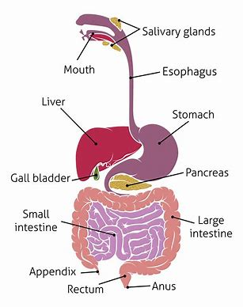

**Stomach**

The length of time to digest chicken breast is determined by each individual and their ability of their metabolism. The stomach produces an enzyme called pepsin (proteolytic Enzyme) which helps to digest proteins. Mechanical digestion in the stomach is achieved by waves of muscular contraction that move along the stomach wall. This enables the stomach to contract and churn the chicken breast and mix it with the stomach juices (gastric juices) for several hours, until the food is converted to a thick, soupy liquid called chyme. Chyme is the result of the gastric juices and bolus mixing together within the stomach to help achieve digestion.

Gastric juice is a digestive juice that contains hydrochloric acid, mucus and digestive enzymes, gastric juices are responsible for chemical digestion in the stomach. The pH level in the stomach is approximately 2-3, due to the hydrochloric acid. The acidic environment allows the enzyme pepsinogen to be converted into pepsin, an active form of enzyme. Pepsin is able to break down proteins into shorter peptides, causing the start to chemical digestion in the stomach. The enzyme pepsin breaks down the long chains of amino acids, so they are broken into shorter chains called polypeptides, which help digest the chicken breast faster. After 2 – 8 hours the stomach contents are gradually pushed into the small intestine.

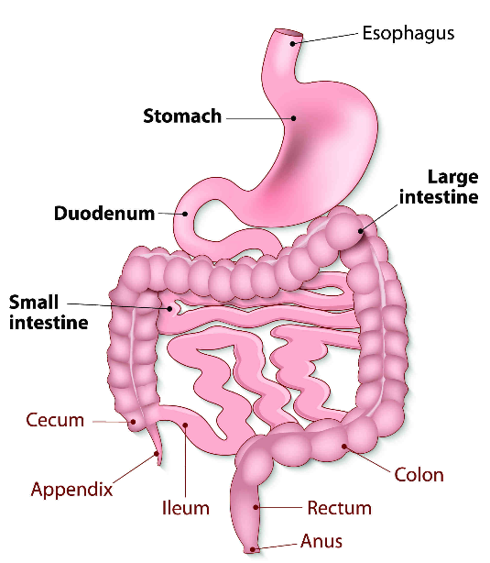

**Small Intestine**

**(Breakdown)**

The chyme leaves the stomach and enters the small intestine were the majority of digestion of protein occurs. The chyme firstly enters the duodenum where the pancreas creates pancreatic juices and bile which is made by the liver and stored in the gall bladder. The pancreas produces digestive juices into the small intestine, which contain more enzymes that further breakdown polypeptides. The two major enzymes produced by the pancreas are trypsin and chymotrypsin. Any fat in the chicken is broken down into fatty acids by the substance of bile along with the protein. The chyme substance moves into another part of the small intestine called the jejunum which absorbs nutrients form digested food into the blood stream. The jejunum absorbs water and moves the chyme substance through the digestive tube. The jejunum is lined with villi which also help with absorption.

**(Absorption)**

The trypsin enzyme activates the protease enzymes and breakdown proteins. The proteins are broken down into tripeptides, dipeptides, and amino acids. The dipeptides, tripeptides and amino acids enter the enterocytes in the small intestine using active transport, which requires ATP. Active transport is a cellular transport where substances move from an area of lower concentration to an area of higher concentration. Once inside the tripeptides and dipeptides are all broken down to single amino acids, which are then absorbed into the blood stream. Absorption is further enhanced by the continual movement of villi which are brought about by the muscular movements of the intestinal walls. The villi are covered with tiny, microscopic projections from their external surfaces, called microvilli. Once the amino acids are in the bloodstream, they are then transported to the liver. The liver distributes amino acids and any further breakdown of the amino acids.

**Material breakdown and use**

The nutrients that are released from the digestion of chicken are absorbed into the body. The fatty acids from the chicken are made into fats are the body’s secondary source of energy after the use of glucose, which is the body’s primary sources of energy. The broken-down amino acids are used within the body for repair and growth within the body, via protein synthesis.

**Large Intestine**

The movement of chicken and food in general move slow taking 18-24 hours to pass through. During this time, most of the remaining water is absorbed so the contents can become more solid and firm.

Bacteria in the large intestine perform a range of useful functions such as, breakdown undigested food, neutralise some of the harmful products within food break down and aiding the absorption of vitamins and minerals. The bacteria within the large intestine breakdown much of the remaining organic compounds. Some of the bacteria withing the large intestine produce vitamins, which are eventually absorbed through the walls of the blood as well as minerals.

The more firm and solid material that is left after the absorption of water and the action of the bacteria within the large intestine make up a substance called faeces.

**Elimination and Faeces**

After faeces pass a major part of the large intestine the substance enters the rectum through the anus. Slightly solid material is left in the colon after water absorption id pushed into the rectum by the process of peristalsis. As the walls of the rectum stretch, the muscles trigger a response known as defecation. Defecation allows the faces substance to be passed out and excreted from the body. Faeces contains water, undigested food material, bacteria, pigments of bile.

**References**

Newman, T. (2022, July 12). *Digestion: How the body breaks down food*. <https://www.medicalnewstoday.com/articles/320014#:~:text=Once%20the%20food%20is%20inside%20of%20the%20mouth%3A,saliva%2C%20salivary%20amylase%2C%20breaks%20it%20down%20into%20starch>.

Vdomwe. (2023, February 27). Why Mom Was Right About How Long Does It Take To Digest Chicken? *Weight Loss | Diet | Lifestyle*. <https://getbellyfix.com/how-long-does-it-take-to-digest-chicken/#How_Long_Does_It_Take_To_Digest_Chicken>

Libretexts. (2021). 8.5: Protein Digestion and Absorption. *Medicine LibreTexts*. <https://med.libretexts.org/Courses/Allan_Hancock_College/Introduction_to_Nutrition_Science_(Bisson_et._al)/08%3A_Protein/8.05%3A_Protein_Digestion_and_Absorption>